**Gayatri Vidya Parishad College of engineering(A), Visakhapatnam**

**Physics Lecture Notes**

**UNIT-1**

**WAVE OPTICS**

***Interference***

Interference and diffraction phenomena can be explained by Huygens wave theory. The first experiment was demonstrated by Thomas Young in 1801 through his double slit experiment.

Interference is an important consequence of superposition of waves.

**Principle of superposition theorem**:

*This principle states that the resultant displacement of a particle of the medium acted upon by two or more coherent waves (equal frequency and constant phase difference) simultaneously is the algebraic sum of the displacements of the same particle due to individual waves, in the absence of the others.*

**Interference:** When two light waves superimpose, then the resultant amplitude or intensity in the region of superposition is different than that of the amplitude or intensity of individual waves. *This modification of intensity in the region of superposition is called interference.* In the interference region one can observe the alternate bright and dark fringes. When the resultant amplitude is the sum of the amplitudes due to two waves, the interference is called constructive interference which produce bright fringe and when the resultant amplitude is equal to the difference of two amplitudes, the interference is known as destructive interference that gives dark fringe. Interference phenomena obey the law of conservation of energy.

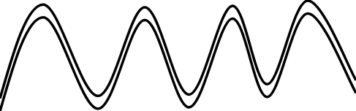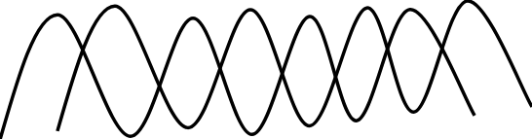

**(a) constructive interference (b) Destructive interference**

**Conditions for sustained interference**

1.The waves from the two light sources must be of the same frequency, narrow and maintain the constant phase difference.

2. The amplitude of two waves should be equal to observe the distinct bright and dark fringes.

3. The two coherent sources must lie close to each other in order to produce interference effect.

4. Back ground should be dark to view interference fringes.

5. Plane of polarization must be the same.

**Stokes principle:** According to Stoke’s principle, when a light wave is reflected at the surface of an optically denser medium, it suffers a phase difference of π, or a path difference of λ/2. It should be remembered that no such phase difference is introduced if the reflection takes place from the surface of rarer medium.

**Interference in thin films due to reflected light (Cosine law):**

Let GH and G1H1 be the two surfaces to a transparent film of uniform thickness t and refractive index μ as shown in Fig. Suppose a monochromatic ray be incident on its upper surface. This ray is reflected along BR and transmitted along BC. BC undergoes internal reflection at C on the G1H1surface and follows the path CD. After refraction at D, the ray finally emerges out along DR1 in air. Obviously DR1 is parallel to BR, but they have some path difference. To determine this path difference, draw a normal DE to the ray BR and normal BF on CD. Extend CD along back ward direction which meets at P. From figure ∠ABN = i, the angle of incidence and ∠QBC = r, the angle of refraction. From the geometry of the figure ∠BDE = i and ∠QPC = r. The optical path difference between the two reflected light rays (BR and DR1) is given by

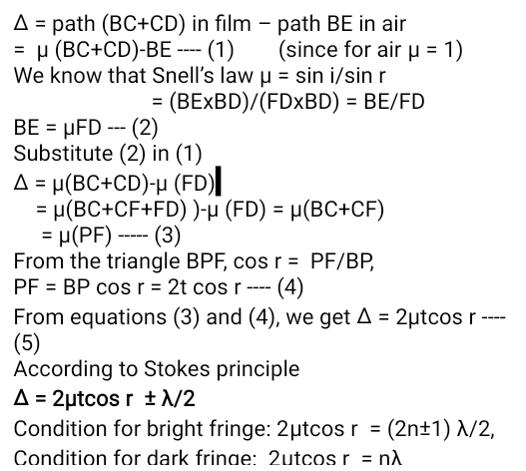

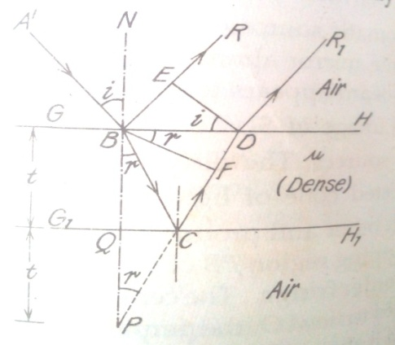

**Newton’s Rings**

When a plano convex lens with its convex surface is placed on a plane glass plate, an air film of gradually increasing thickness (wedge shaped air film) is formed between the two. If monochromatic light is allowed to fall normally with the help of another glass plate inclined at an angle 45o to the incident light, then alternate dark and bright circular fringes are observed through the travelling microscope as shown in Fig. (a). The fringes are circular in nature because the locus of the points having same thickness of the air film in the case of wedge shaped air films. Newton’s rings are formed because of the interference between the waves reflected from the top and bottom surfaces of the air film formed between the plates as shown in Fig. (b)

The path difference between these rays 1 and 2 is 2μtcos r ± λ/2

Since r = 0 (i = 0), μ = 1, Δ = 2t ± λ/2

At the point of contact t = 0, the path difference is only λ/2. Hence the central spot is dark.

The condition for bright fringe is 2t = (2n±1) λ/2 where n = 1,2,3,…..

and the condition for dark fringe is 2t = n λ

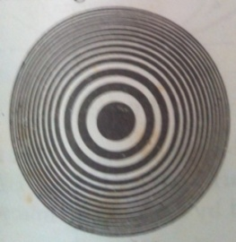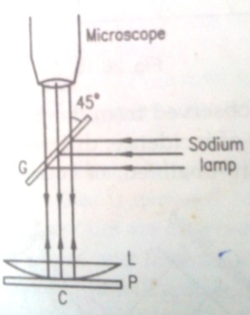

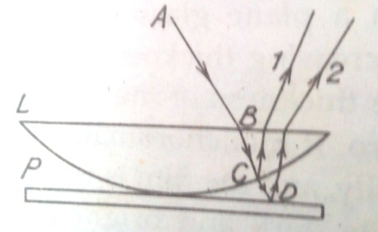

Fig. (a) Fig. (b) Fig. (c)

Now let us calculate the diameter of these fringes. Let LOL’ be the lens placed on the glass plate AB. The curved surface LOL’ is part of the spherical surface with the centre at C. Let R be the radius of curvature and rn be the radius of nth Newton’s ring corresponding to constant film thickness t.

From the property of the circle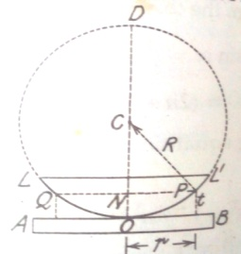

NP x NQ = NO x ND

rn x rn = t (2R-t) = 2Rt – t2 ≈ 2Rt

rn2 = 2Rt

t = rn2/2R

Thus for a bright fringe rn2 = (2n±1) λR/2

Dn2 = 2 λR (2n-1)

For dark fringe Dn2 = 4n λR

Thus the diameter of the rings are proportional to the square roots of the natural numbers.

In the case of transmitted light, the conditions for bright and dark fringes are interchanged. Similarly the diameters of dark and bright fringes also get interchanged. The central fringe appears as bright.

By measuring the diameter of the Newton’s rings, it is possible to calculate the wavelength of light.

The diameter of the nth dark fringe Dn2 = 4n λR

The diameter of the mth dark fringe Dm2 = 4m λR

Dm2 - Dn2= 4(m-n)λR

**λ = (Dm2 - Dn2) /4(m-n)R**

**Applications of interference**

**1. Testing of flatness of surfaces**

In modern technology thin film interference is widely used. One of the applications is testing of flatness of surfaces. Machine components retain surface irregularities left after machining. The extent of suitability of the component for a particular application depends on the irregularities which act as sources of stress leading to fatigue cracks. The surfaces of components which are going to be subjected to high stress and load reversals are therefore required to have a smooth surface finish.

The smoothness of a surface can be quickly inspected visually by keeping an optical flat on the component at an angle and illuminating it with a monochromatic light as shown in figure. The air wedge formed between the component and optical flat produces straight and equidistant fringes if the component surface is smooth. If the fringes are curved towards the contact edge, the surface is concave and if the fringes curve away, it is convex.

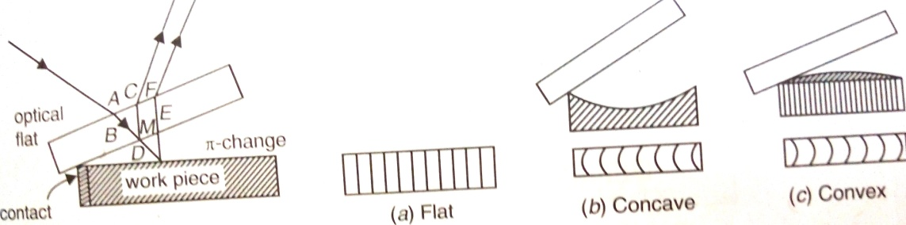

**2. Anti-Reflecting coatings**

Optical instruments such as telescope and cameras use multicomponent glass lenses. When light is incident on the lens, part of the incident light is reflected away and that much amount of light is lost and wasted. When more surfaces are there, the number of reflections will be large and the quality of the image produced by a device will be poor. In case of solar cells, which operates on sunlight, the electrical energy produces will be less because of the loss of part of light energy due to reflection, at each cell surface. It is found that coating the surface with a thin transparent film of suitable refractive index can reduce such loss of energy due to reflections at surface. Such coatings are called antireflection coatings. “Antireflection coatings are thin transparent coatings of optical thickness of one quarter wavelength given on a surface in order to suppress reflections from the surface”.

Alexander Smakula discovered in 1935 that the reflections from a surface can be reduced by coating the surface with a thin transparent dielectric film.

A thin film can act as an antireflection coating if it meets the following two conditions:

(i) Phase condition: The waves reflected from the top and bottom surfaces of the thin film are in opposite phase such that their overlapping leads to destructive interference, and

(ii) Amplitude condition: The waves have equal amplitudes

The above conditions enable us determine the required thickness of the films and refractive index of the material.

***Diffraction***

*When light falls on an obstacle or small aperture whose size is comparable with wavelength of light, there is a departure or deviation from the straight line propagation, the light bends round the corners of the obstacle or aperture and enters in the geometrical shadow. This bending of light is called diffraction.*

The diffraction phenomenon was interpreted by Fresnel. According to Fresnel, the diffraction phenomenon is due to mutual interference of secondary wavelets originating from various points of wave front which are not blocked off by the obstacle. It should be remembered that the diffraction effects are observed only when a portion of wave front is cut off by some obstacle.

**Types of Diffraction**

Diffraction phenomena can be divided into the following two general classes

(1) ***Fresnel diffraction***: In this case, source and screen are placed at a finite distances from the aperture or obstacle having sharp edges. In this case no lenses are used for making the rays parallel or convergent. The incident wave front is either spherical or cylindrical.

(2) ***Fraunhofer’s diffraction***: In this case, source and screen are placed at infinity. In this case the wave front which is incident on the aperture or obstacle is plane. Here lenses are used.

**Fraunhofer’s diffraction due to single slit**

Consider a narrow slit AB of width e. Let a plane wave front WW1 of monochromatic light of wavelength λ propagating normal to the slit be incident on it. Let the diffracted light beam focused by means of a convex lens on a screen. According to Huygen and Fresnel, every point of the wave front in the plane of the slit is a source of secondary spherical wave lets which spreads out the light in all directions. The secondary wave lets travelling normal to the slit, i.e., along the direction OPo, are brought to focus at Po by the lens. Thus Po is a bright central image. The secondary wave lets travelling at an angle θ with the normal are focused at a point P1 on the screen. The point P1 is of the minimum intensity depending upon the path difference between the secondary waves originating from the corresponding points of the wave front. In order to find out intensity at P1, draw a perpendicular AC on BR. The path difference between secondary wavelets A and B in direction θ = BC = AB sin θ = e sin θ and corresponding phase difference = 

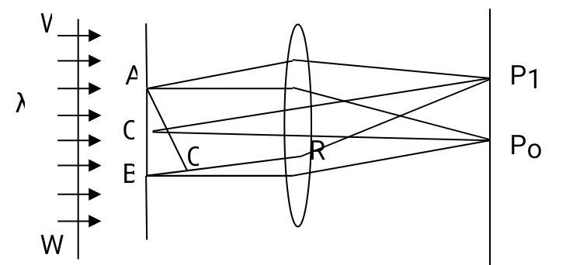

W

P

A θ P1

Q

e R Po

B C

W1

Let us consider that the width of the slit is divided into n equal parts and the amplitude of the wave from each part is a. The phase difference between any two consecutive waves from these parts would be =  = d (say)

Using the vector additional method the resultant amplitude R is given by

R = a  = a 

Let  = α R = a , R = a , R = na 

R = A  I = R2 = A2( )2

***Principle maxima***: The expression for the resultant amplitude R can be written in ascending powers of α is as

R =  [α – α3/3!+ α5/5! – α7/7! + .........]

R = A [1 – α2/3!+ α4/5! – α6/7! + .........]

If the α terms vanish, the value of R will be maximum, i.e., α = 0

α =  = 0, or Sin θ = 0, θ = 0

Now maximum value of R is A and the intensity is proportional to A2. The condition θ = 0, means that this maximum is formed by those secondary wavelets which travel normal to the slit. This maximum is known as principle maximum.

***Minimum intensity positions***: The intensity will be minimum when  = 0 but α ≠ 0.

The values of α which satisfy this equation are α = ± π, ± 2π, ± 3π, .......... = ± mπ

Or  = ± mπ, or e sin θ = ± mλ, where m = 1, 2, 3, .........

In this way we obtained the points of minimum intensity on either side of the principle maximum. The value of m = 0 is not admissible, because for this value θ will be zero and this corresponds to principle maximum.

***Secondary maxima:*** In addition to the principle maximum at α = 0, there are weak secondary maxima between equally spaced minima. The positions can be obtained by differentiating the expression I with respect to α equating to zero. We have,



 = 0

Either sin α = 0 or  = 0

The equation sin α = 0 gives the values of α (except 0) for which the intensity is zero on the screen. Hence the positions of the maxima are given by the roots of the equation  = 0 or α = Tanα

The values of α satisfying the above equation are obtained graphically by plotting the curves y = α, y = Tan α on the same graph.

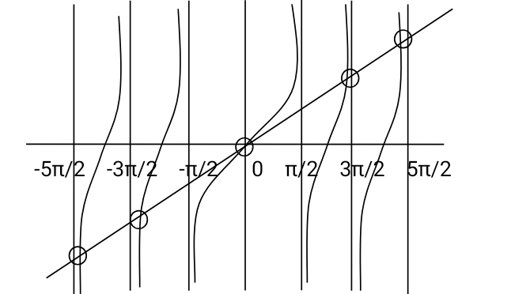

The point of intersection of two curves give the value of α which satisfy the above equation. The plots of y = α and y = Tan α are shown in figure. The points of intersections are α = ± 3π/2, ± 5π/2, ± 7π/2, ........

Intensity distribution curve

I

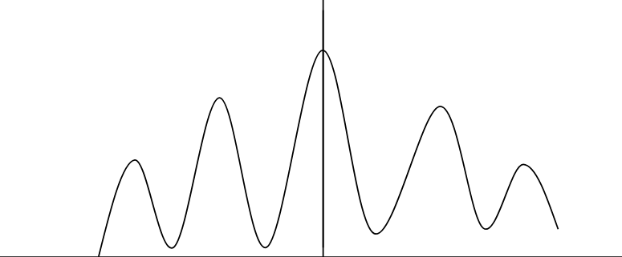

-3π -2π -π 0 π 2π 3π α

**Diffraction due to plane transmission grating**

Construction: An arrangement consisting of large number of parallel slits of the same width and separated by equal opaque spaces is known as diffraction grating. Gratings are constructed by ruling equidistant parallel lines on a transparent material such as glass with a fine diamond point. The ruled lines are opaque to light while the space between any two lines is transparent to the light and acts as slit. This is known as plane transmission grating. When the spacing between the lines is of the order of the wavelength of the light, then an appreciable deviation of the light is produced.

Working: Consider a plane transmission grating of N slits per cm placed perpendicular to the plane of the paper. Let e be the width of each slit and d be the width of each opaque part then (e+d) is known as grating element. XY is the screen placed perpendicular to the plane of the paper. Suppose a parallel beam of monochromatic light of wavelength λ be incident normally on the grating. By Huygen’s principle, each of the infinite points in the slits sends secondary wavelets in all directions. The secondary wavelets travelling in the same direction of incident light will come to focus at a point Po of the screen. Now considering the secondary wavelets travelling in a direction incident at an angle θ with the direction of the incident light, these waves reach a point P1 on the passing through the convex lens in different phases. As a result dark and bright fringes appear on both sides of the central maximum.



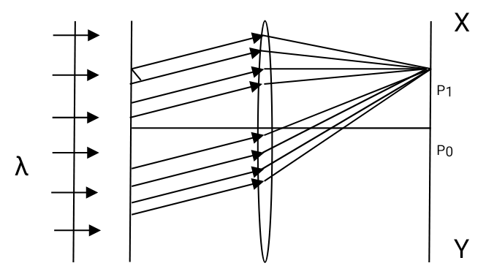

The intensity at P1 will depend on the path difference between the secondary waves originating from the respective points A and C of two neighbouring slits. In the figure AB = a and BC = b. The path difference between the secondary waves starting from A and C is equal to AC sin θ.

But AC = AB+BC = a+b; path difference = AC sin θ = (a+b) sin θ

The point P1 will be maximum intensity if this path difference is equal to integral multiples of λ.

In general (a+b)sin θm = mλ

where θm is the direction of the mth principal maximum. The minimum is obtained in between two maxima. Similar maxima and minima are obtained on either side of the central maximum. Thus, on each side of the central maximum at P, principal maxima and minimum intensity are observed due to diffracted light.

The position of the mth minima is given by (a+b)sin θm = (2m+1)λ/2

When illuminated by a beam of monochromatic radiation, the system produces N wavelets at an angle θ, each of the amplitude = A( ). The phase difference between successive wavelets δ = 2πdsinθ/λ

In order to know the resultant intensity at each point along with their positions, the following equation is used. 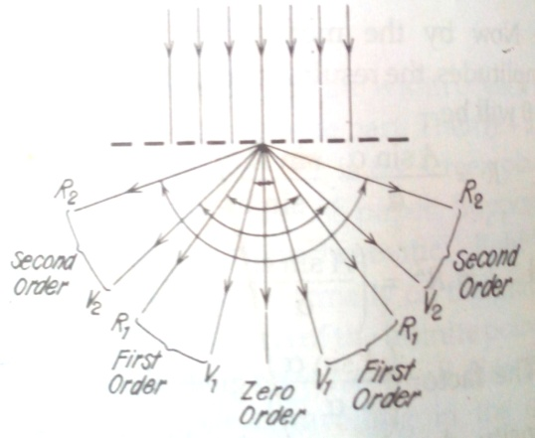

I = = R2 = A2( )22

where β = πdsinθ/λ

Principal maxima: When Sin β = 0; we get the maximum intensity. Therefore β = ± nπ (n = 0, 1, 2, 3, ...)

After applying the L’Hospital rule, we obtain the resultant intensity for maxima, i.e. I = A2( )2 N2

As these maxima are very intense, they are called principle maxima. The equation for the direction of the principal maxima is (a+b)sin θ = ± nλ which is known as grating equation. In another words **sin θ = ± nNλ**, where N = 1/(a+b), no. of lines per cm

Minima: The intensity is zero when sin Nβ = 0, but β≠0

Nβ = ± mπ where m can take all integral values except 0, N, 2N, 3N, .....because these values give the positions of the principal maxima. The positive and negative sign indicate that the minima of a given order lie symmetrically on both the sides of the central principal maxima.

m = 0 gives principal maximum of zero order while m = 1, 2, 3, ... (N-1) give the minima. When m = N, gives the principal maximum of first order. Thus, between zero order and first order principal maxima, we have (N-1) minima. Between two such consecutive minima, the intensity has to be maximum, and these maxima are known as secondary maxima. The secondary maxima are not visible in the grating spectrum as the number of slits is very large.

Intensity distribution curve is

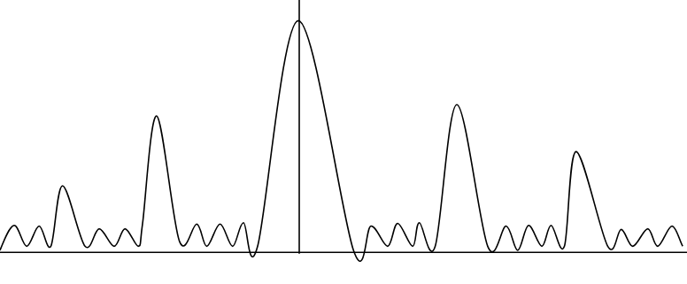

n=2 n = 1 n=0 n = 1 n = 2

***Polarization***

Interference and diffraction phenomena established that light travels in the form of waves. But, the two phenomena did not offer any hint about the nature of the light waves, whether they are longitudinal or transverse waves, or whether the constituent vibrations are linear or circular. The knowledge of polarization is essential for understanding the propagation of electromagnetic waves propagating through wave-guides and optical fibers.

Waves basically two types: Longitudinal and Transverse

Longitudinal wave is a wave in which particles of the medium oscillate to and fro along the direction of propagation. Transverse wave is a wave in which every particle of the medium oscillates up and down at right angles to the direction of wave propagation.

In a longitudinal wave, all directions perpendicular to the wave propagation are equivalent. On the other hand, a preferential direction normal to the wave propagation exists in a transverse wave. The existence of preferential direction for a transverse wave leads to the characteristic phenomena known as *Polarization*.

Light waves are made up of electric and magnetic field vectors oscillate perpendicular to each other and to the direction of wave propagation. The vibrating electric field vector and the direction of propagation of the wave constitute a plane. There are an infinite number of such planes around the direction of propagation. In an ideal light wave, the vibrations of electric vector are confined to a single plane. In practice, light sources emit a mixture of light waves with random orientation of vibration planes. These planes give rise to symmetry about the wave propagation direction. As a result, the transverse nature of the wave gets concealed. “*The process of removing the symmetry and bringing in one-sidedness in the light wave is called Polarization”.*

Types of Polarized light: Linear, Circular, Elliptical

**Production of Plane polarized light:**

**Polarization by reflection:**

E.L. Malus discovered in 1808 polarization of light by reflection. He noticed that when natural light is incident on a smooth surface, at a certain angle the reflected beam is plane polarized. When light wave is incident on a boundary between two dielectric materials, part of it is reflected, and part of it is transmitted. Figure shows an unpolarized light beam AB incident on a glass surface. The incident ray AB and the normal NBN′ define the plane of incidence. The electric vector E of the ray AB can be resolved into two components, one perpendicular to the plane of incidence and the other lying in the plane of incidence. The perpendicular component is represented by dots and is called the s-component. The parallel component is represented by the arrows and is called the p-component.

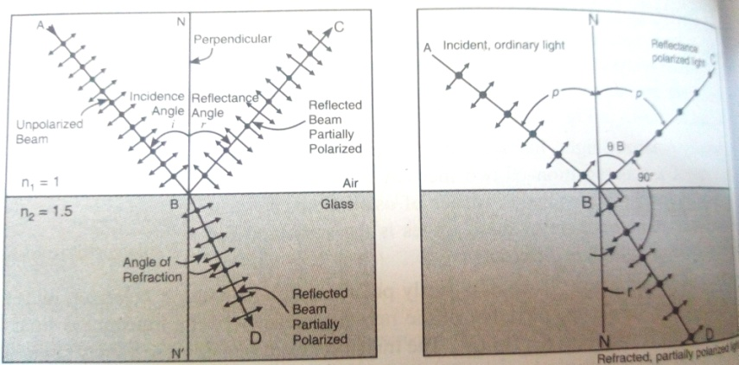

In case of completely unpolarized light the two components are of equal magnitude. At a particular angle θB, the reflection coefficient for p-component goes to zero and the reflected beam does not contain any p-component. It contains only s-component and is totally plane polarized. The angle θB is called the polarizing angle or Brewster’s angle.

“*Polarizing angle is the angle* θB *at which the reflected ray has no p-component and contains only s-component when a light wave is incident on a boundary between two dielectric materials.”*

He also derived that when the light passing through the polarizer and then analyzer, the intensity of output light depends on the angle between polarizer and analyzer.

i.e **I = I0 cos2 θ**, where I0 is the intensity after passing through the polarizer, θ.

**Brewster’s law**: Brewster found that polarizing angle depends upon the refractive index of the medium.

“*The tangent of the angle at which polarization is obtained by reflection is numerically equal to the refractive index of the medium*”.

If θB is the angle and μ is the refractive index of the medium, then μ = tan θB  is known as the Brewster’s law.

If natural light is incident on a smooth surface at the polarizing angle, it is reflected along BC and refracted along BD, as shown in figure. Brewster found that the maximum polarization of reflected ray occurs when it is at right angles to the refracted ray. It means that θB + r = 90o.

r = 90o - θB, therefore according to Snell’s law, (sin θB)/(sin r) = μ2/μ1

where μ2 is the absolute refractive index of reflecting surface and μ1 is the refractive index of the surrounding medium.

Therefore, (sin θB)/(sin 90o - θB) = μ2/μ1

(sin θB)/(cos θB) = μ2/μ1

As μ = 1 for air, taking μ2 = μ, we get tan θB = μ2/μ1 = μ

**Applications of Brewster’s law:**

1. Refractive index of opaque material can be determined.

2. Polarizing angle for any material can be calculated.

3. Glasses can be used as Brewster windows in gas lasers.

4. Can transmit light into or out of the optical fiber without any reflection losses.

**Polarization by refraction - Pile of plates**

When unpolarized light falls on a glass surface at Brewster angle, the reflected light is totally polarized, while the refracted light is partially polarized. If natural light is transmitted through a single plate, the transmitted beam is only partially polarized. If a stack of glass plates is used instead of a single plate, reflection from successive surface occur leading to the filtering of the s-component in the transmitted ray. Ultimately, the transmitted ray consists of p-component alone. It is found that a stack of about 15 glass plates is required for this purpose. The glass plates are supported in a tube of suitable size and inclined at an angle of about 33o to the axis of the tube, as shown in figure. 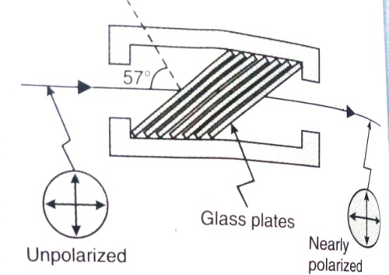

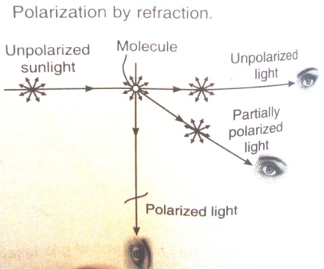

Such an arrangement is called pile of plates. Unpolarized light enters the tube and is incident on the plates at Brewster angle and the transmitted light will be totally polarized parallel to the plane of incidence.

**Polarization by Double refraction**

When a beam of unpolarized light is incident on the surface of an anisotropic crystal such as calcite or quartz, it is found that it will separate into two rays that travel in different directions. This phenomenon is called birefringence or double refraction. The two rays are known as ordinary ray (O-ray) and extraordinary ray (e-ray), which are linearly polarized in mutually perpendicular directions. A single linearly polarized ray is obtained in practice through elimination of one of the two polarized rays. Along the optic axis they travel with same velocity, but in other directions with different velocities as the refractive index of e-ray depends on the direction of propagation.

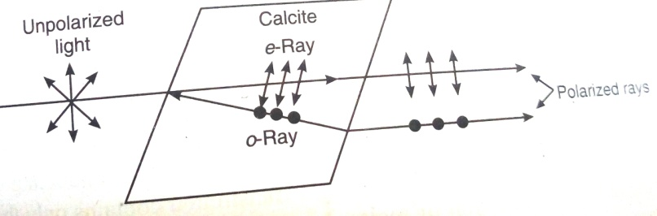

**Nicol Prism**

Nicol prism is a polarizing device fabricated from a double refracting crystal. A Nicol prism is made from calcite crystal. William Nicol designed it in 1820. A rhomb of calcite crystal about three times as long as it is thick, is obtained by cleavage from the original crystal. The ends of the rhombohedron are ground until they make an angle of 68o and 112o instead of 71oand 109o, respectively, with the longitudinal edges. This piece is then cut into two along a plane perpendicular both to the principal axis and to the new end surfaces PM and NQ. The two parts of the crystal are then cemented together with Canada balsam, whose refractive index lies between the refractive indices of calcite for the o-ray and e-ray. μo = 1.66, μe = 1.486 and μc = 1.55. The position of the optic axis is shown in figure. The refractive index for e-ray depends upon the direction in which e-ray is propagating in the crystal. The difference between the refractive index between o-ray and that for e-ray goes on increasing with the angle between the two rays in the crystal. When this angle is 90o, the difference is maximum. Thus, for a fixed value for μo, the μe has its maximum or minimum value in perpendicular direction. In the above μe = 1.486 represents the minimum value.

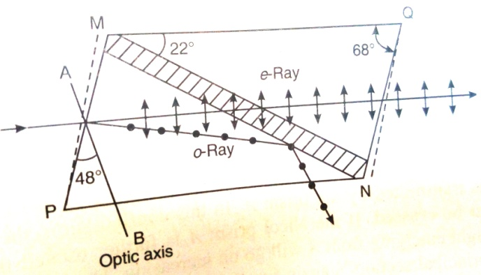

Unpolarized light is made to fall on the crystal as shown in figure at an angle of about 15o. The ray after entering the crystal suffers double refraction and splits up into o-ray and e-ray. The two rays with their directions of vibrations are as shown in figure. The values of the refractive indices and the angle of incidence at the Canada balsam layer are such that the e-ray is transmitted while the o-ray is completely absorbed. Then we get only the plane polarized e-ray coming out of the Nicol. Thus, the Nicol works as a polarizer.

For studying the optical properties of transparent substances, two Nicols are used – one as a polarizer and the other as an analyzer.

When two Nicol prisms P and A are placed adjacent to each other as shown in Figure, one of them acts as a polarizer and the other acts as an analyser. If unpolarized ray of light is incident on the Nicol prism P, a linearly polarized e-ray emerges from P with its vibration direction lying in the principal section of P. The state of the polarization of the light coming from the polarizer P can be examined with another polarizer A, which for convenience is called an analyser. Let now this ray be incident on the second Nicol prism A, whose principal section is parallel to that to P. The vibration direction of the ray will be in the principal section of A and hence it is transmitted unhindered through the analyser A.

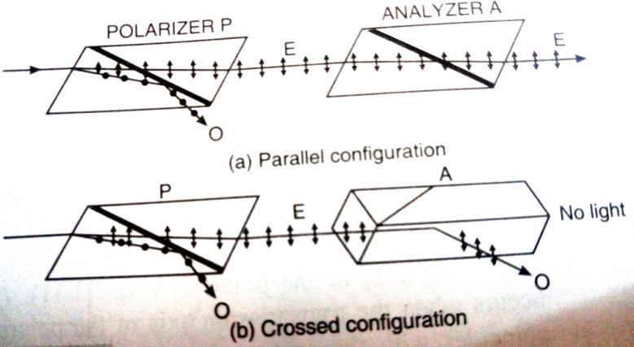

If the Nicol prism A is slowly rotated, the intensity of the e-ray reduces in accordance with Malus law. When its principal section becomes perpendicular to that of the Nicol prism P, the vibrations of the ray, emerging from P and incident on A, will be perpendicular to the principal section of A. In this position the ray behaves as o-ray inside the prism A and is totally internally reflected by the Canada balsam layer. Hence no light is transmitted by the prism A. In this configuration, the two Nicol prisms P and A are said to be crossed. If the Nicol prism A is further rotated through another 90o, the intensity of light emerging from A will go on increasing. The intensity will become a maximum when its principal section is again parallel to that of the prism P. Thus, the prism P produces linearly polarised light while the prism A detects it. Hence the prism P is called a polarizer and the prism A an analyser.

**Retarders**

A retarder is a uniform plate of anisotropic double refracting material having the optic axis parallel to its refracting faces that resolves a light wave into two perpendicular linear polarization components and produces a phase difference between them. They are also called as wave plate quarter-wave plates, half wave plates and full wave plates.

**Quarter wave plate**

A quarter wave plate is a retarder whose thickness adjusted such that it introduces a quarter wave (λ/4) path difference of a phase difference of 90o between the e-ray and o-ray propagating along the same direction but with different velocities through it.

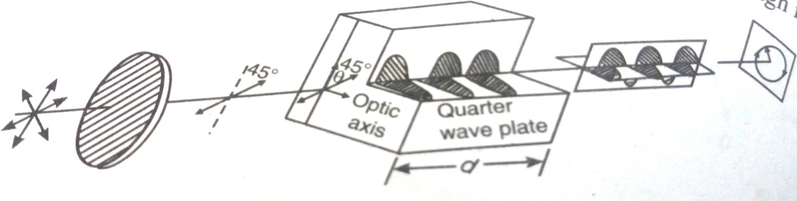

Figure shows the concept of working of quarter wave plate. The optical path difference would be developed between e-ray and o-ray is

(μo-μe)d = λ/4, therefore d = λ/4(μo-μe)

A quarter wave plate introduces a phase difference between e-ray and o-ray of 90o. A quarter wave plate is used for producing elliptically and circularly polarized light. It converts plane polarized light into elliptically and circularly polarized light depending upon the angle of incident light vector with optic axis of the quarter wave plate.

**Half wave plate**

A half wave plate is a retarder whose thickness adjusted such that it introduces a half wave (λ/2) path difference of a phase difference of 180o between the e-ray and o-ray propagating along the same direction but with different velocities through it.

When the two waves combine, they yield a plane polarized wave, which has its plane of polarization rotated through an angle of 2θ. The half wave plate will invert the handedness of elliptical or circular polarized light, changing right to left and vice versa. Figure shows the concept of working of half wave plate.

The optical path difference would be developed between e-ray and o-ray is

(μo-μe)d = λ/2, therefore d = λ/2(μo-μe) (for –ve crystals)

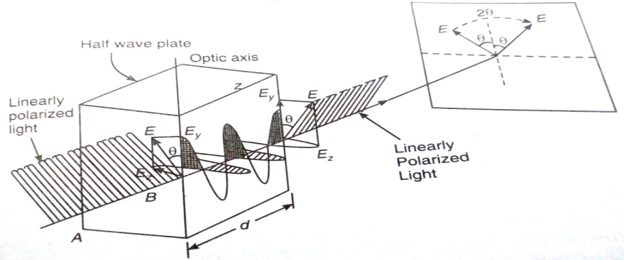

(i) When the optical path difference is 0 or an even or odd multiple of λ/2, the resultant light wave is linearly polarized.

(ii) When the optical path difference is λ/4, the resultant light wave is elliptically polarized.

(iii) In the particular instance when the wave amplitude are equal and the optical path difference is λ/4, the resultant light wave is circularly polarized.

**Applications of Polarization**

(i) **Sunglasses**: Using sunglasses glare can be avoided. Polarized sunglasses contain polarizing filters that are oriented vertically with respect to the frames. As the reflected light is partially polarized, light waves having their **E** oriented in the same direction as the polarizing lenses and perpendicular to the reflecting surface are passed through. On the other hand, light waves with **E** oriented parallel to the reflecting surface (and perpendicular to the filters in the lenses) are stopped. Thus, polarized sunglasses remove the glare from an illuminated surface. A polarizing filter on a camera helps reduce shiny reflections.

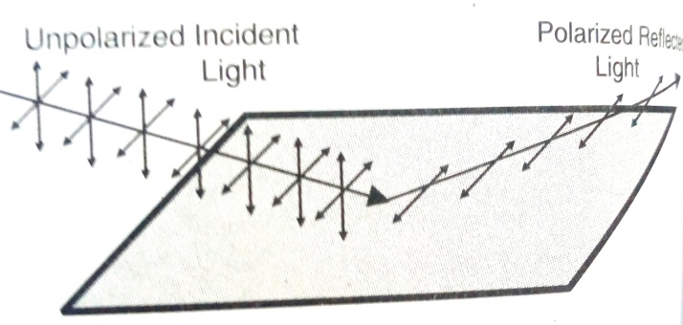

(ii) **Photography**: Polarization by scattering occurs as light passes through atmosphere. The scattered light gives glare. By using a polarizing filter to the camera the problem can be eliminated. As the filter is rotated, the partially polarized light is stopped and the glare is minimized. Thus, a vivid blue sky as the back drop of a beautiful fore ground is captured using polarizing filters.

